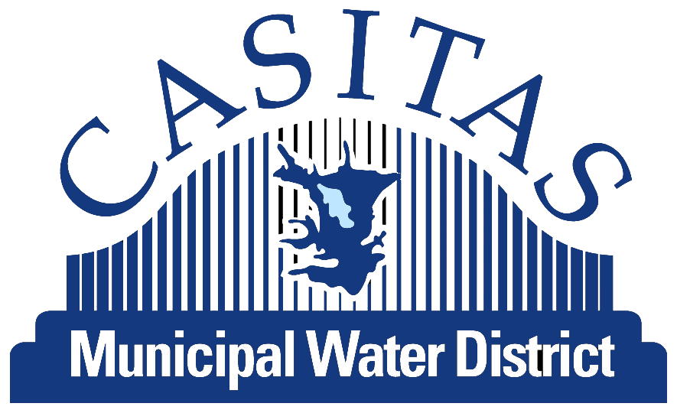

Board Special Meeting Agenda

Russ Baggerly, Director
Angelo Spandrio, Director
Brian Brennan, Director
Pete Kaiser, Director
James Word, Director

CASITAS MUNICIPAL WATER DISTRICT
Special Meeting to be held at the
Casitas Board Room
1055 Ventura Ave.
Oak View, CA 93022
January 12, 2019 @ 10:00 A.M.

Right to be heard: Members of the public have a right to address the Board directly on any item of interest to the public which is within the subject matter jurisdiction of the Board. The request to be heard should be made immediately before the Board's consideration of the item. No action shall be taken on any item not appearing on the agenda unless the action is otherwise authorized by subdivision (b) of ¶54954.2 of the Government Code and except that members of a legislative body or its staff may briefly respond to statements made or questions posed by persons exercising their public testimony rights under section 54954.3 of the Government Code.

1. Roll Call

2. Public comments (Items not on the agenda – three minute limit).

3. Closed Session

  - PUBLIC EMPLOYMENT (Gov. Code §54957(b)(1))

Title: General Manager

  - CONFERENCE WITH LEGAL COUNSEL – EXISTING LITIGATION (Government Code §54956.9(a)
Santa Barbara Channelkeeper v. State Water Resources Control Board; City of San Buenaventura, San Francisco County Superior Court, Case No. CPF-14-513875.

4. Adjournment.

If you require special accommodations for attendance at or participation in this meeting, please notify our office 24 hours in advance at (805) 649-2251, ext. 113. (Govt. Code Section 54954.1 and 54954.2(a)).

