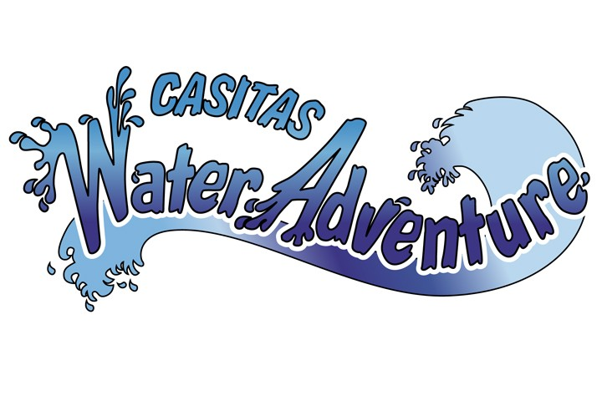

Group/Party Rates & Accommodations

(Monday thru Friday Only - Excluding Major Holidays)

Group/Party Rate: Requires purchase of 25 or more single splash tickets.
Includes:
○ Free parking for up to 1 vehicles (any size). Must park at the Santa Ana Launch Ramp Parking Lot.
○ One free counselor admission for every 10 paid admissions

Large Group/Party Rate: Requires purchase of 60 or more single splash tickets.
Includes:
○ Free parking for up to 4 vehicles (any size). Must park at the Santa Ana Launch Ramp Parking Lot.
○ One free counselor admission for every 10 paid admissions.

○ Group/Party rates apply only to prepaid tickets purchased for a specific single-day use.

○ Reservations must be made in advance of the date of the visit and are subject to availability.

○ No refunds will be made.

○ The original number of group tickets purchased cannot be changed.

○ “Counselor” is defined as an adult (at least 18 years of age) responsible for the safety, well-being, and behavior of their group/party participants.

Planning a special occasion such as a birthday party? A reserved area can be provided for an additional cost. Please contact our Group Sales Coordinator at 805-649-1122.

